7.3B – 2 (R) three W
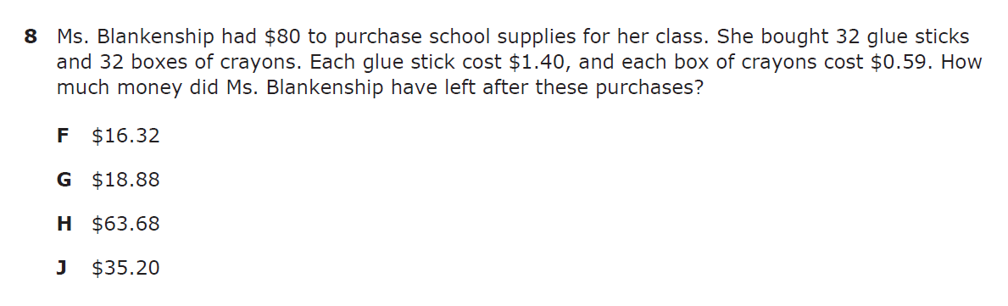

7.3B – 2 (R) four X
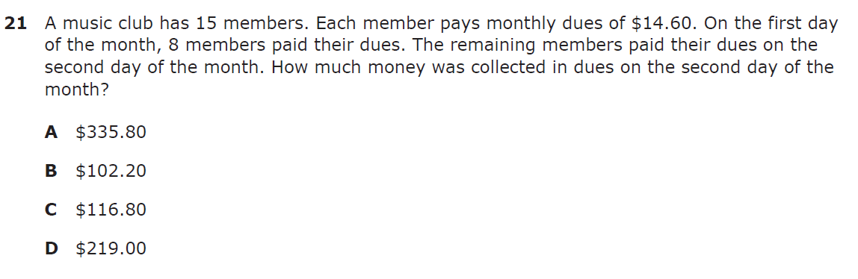

7.3B – 2 (R) five Z
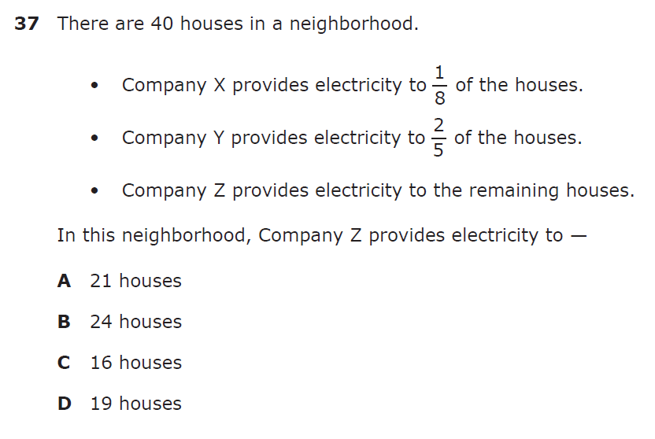

7.3B – 2 (R.) two W

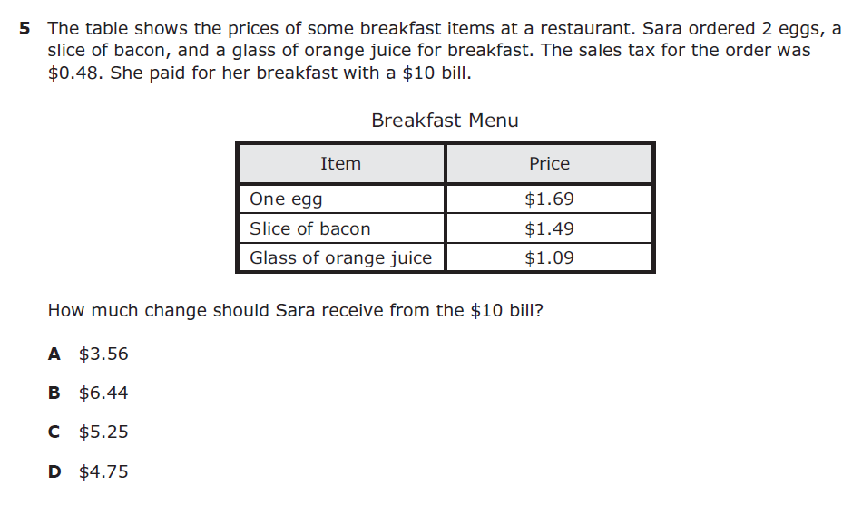
7.3B – 2 (R.) three Y
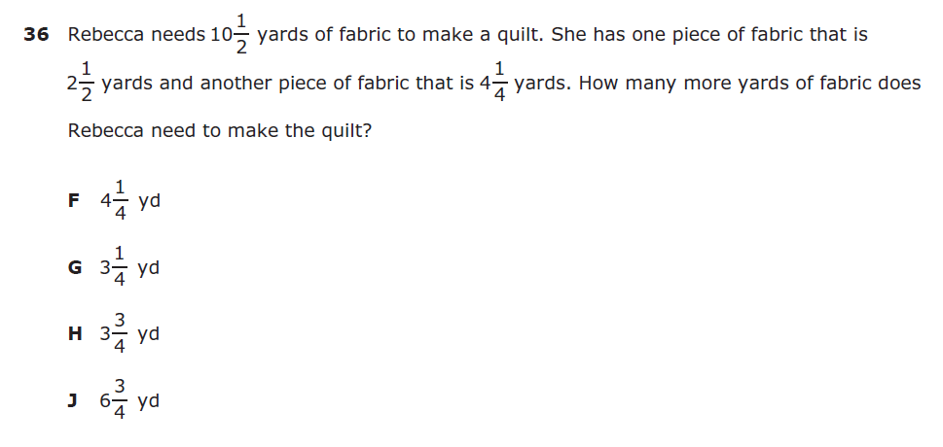

7.3B – 2 (R.) three Z
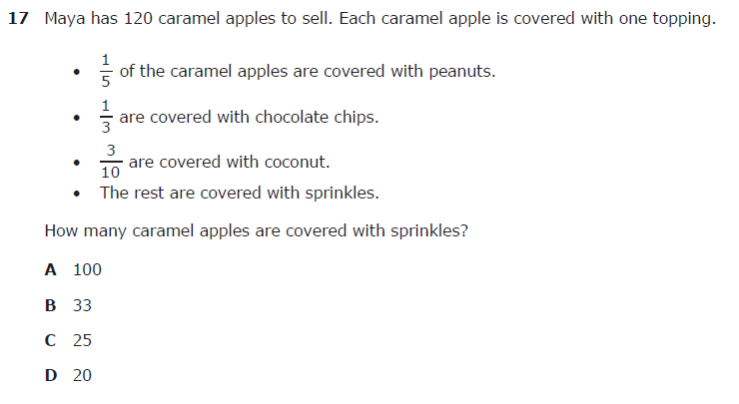

7.3B – 2 (R.) three 4.99
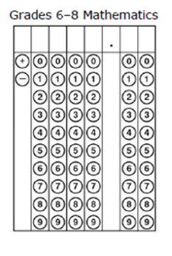
7.4A – 2 (R) six W

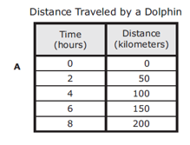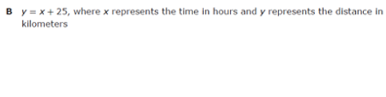
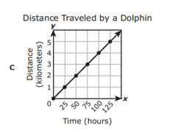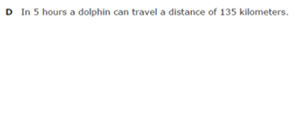
7.4A – 2 (R) seven Z
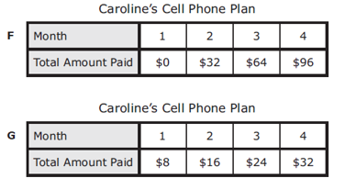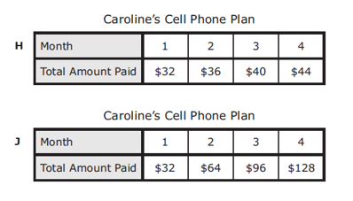

7.4A – 2 (R) eight X
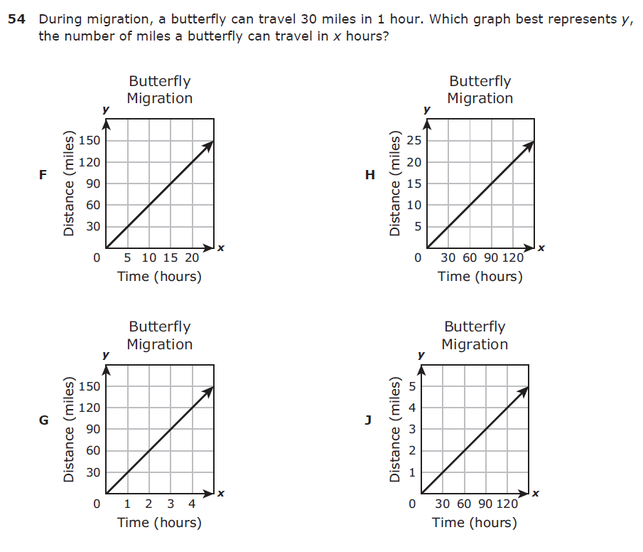
7.4A – 2 (R.) four Y
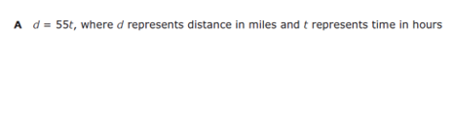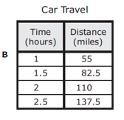

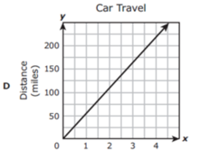

7.4A – 2 (R.) five Y
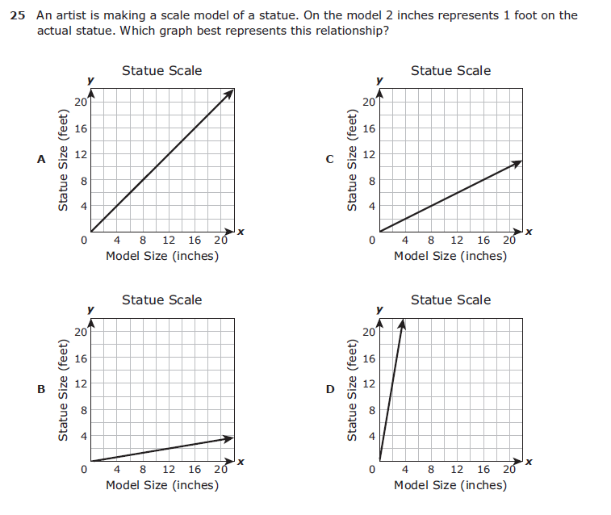
7.4A – 2 (R) four Z
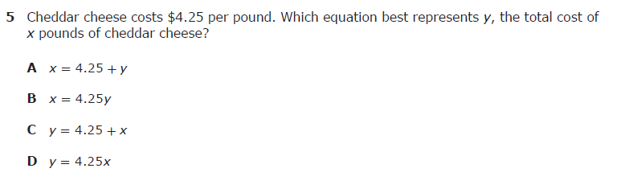

7.4A – 2 (R) five X
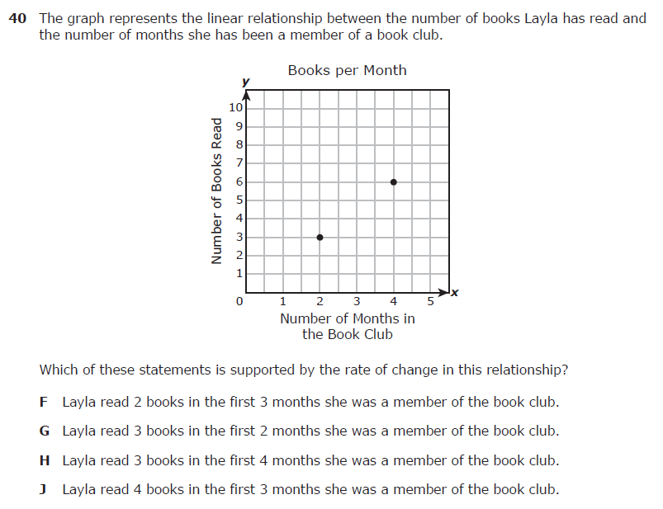
7.4D – 2 (R) ten Y
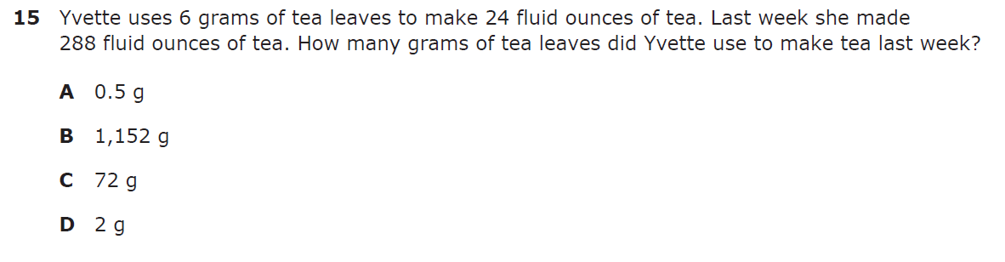

7.4D – 2 (R) eleven X
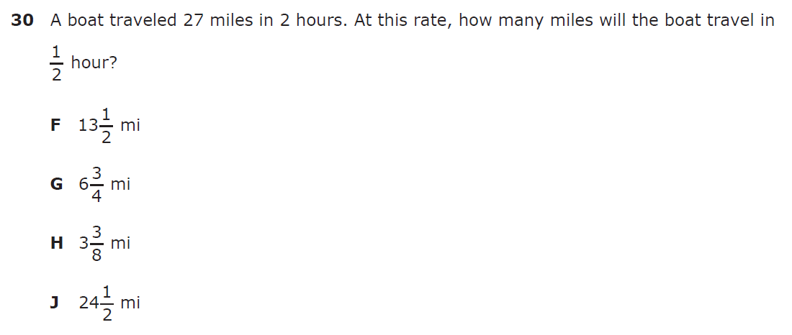

7.4D – 2 (R) twelve W
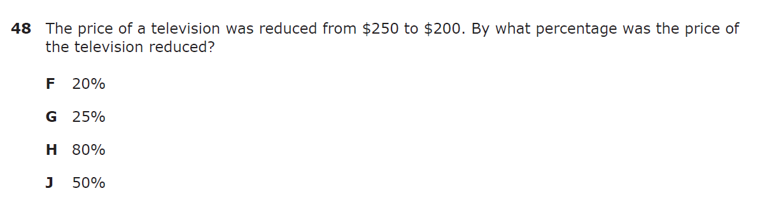

7.4D – 2 (R.) seven X
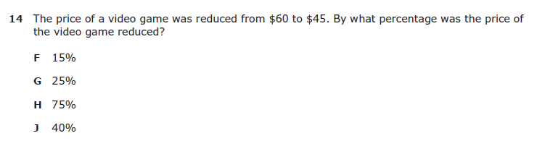

7.4D – 2 (R.) eight X
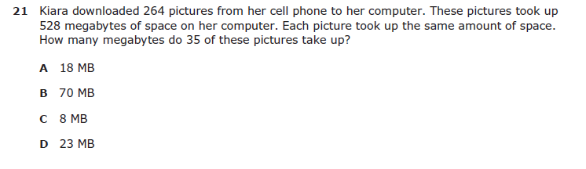

7.4D – 2 (R.) Nine X
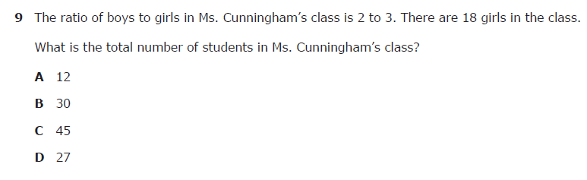

7.4D – 2 (R.) Ten W
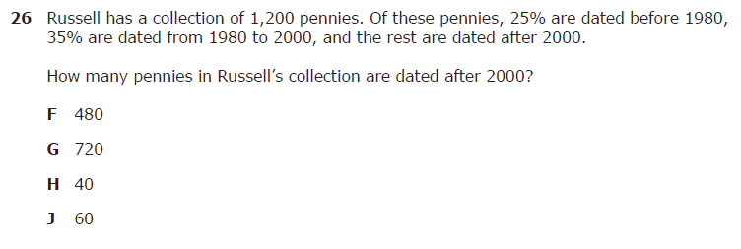

7.5C – 3 (R) fifteen 6.04
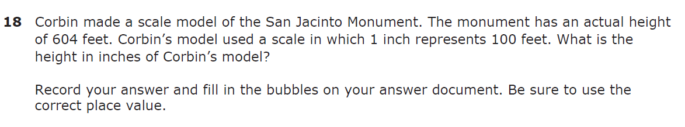

7.5C – 3 (R) sixteen W
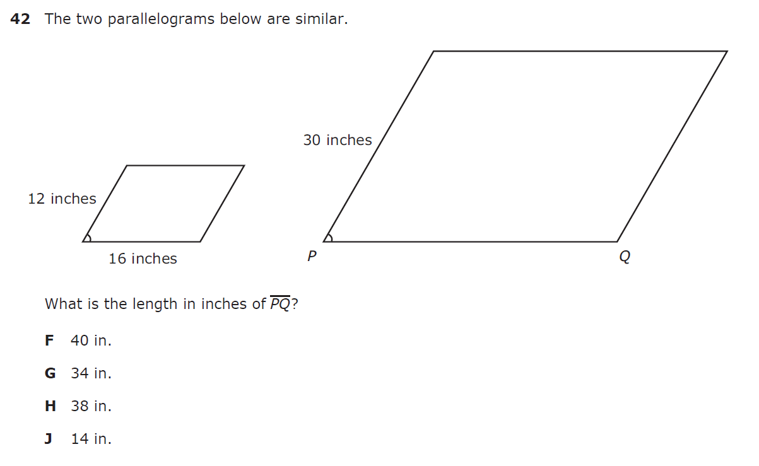

7.5C – 3 (R) seventeen Y
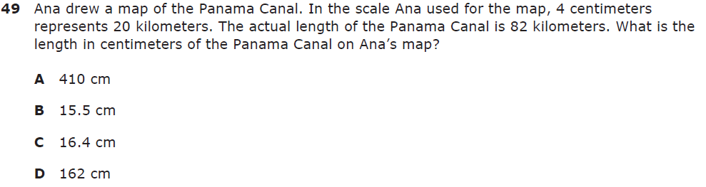

7.5C – 3 (R) eleven W
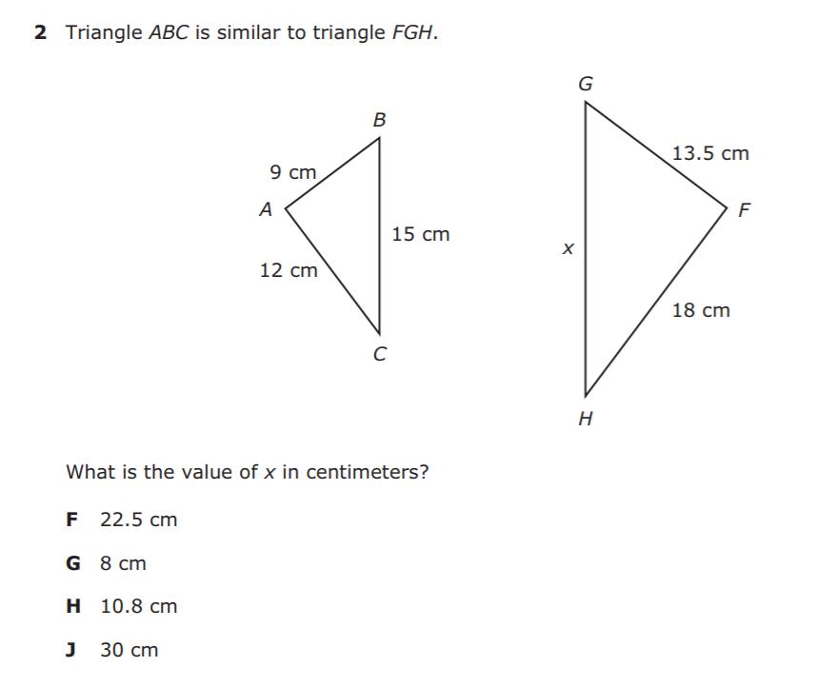
7.5C – 3 (R) twelve 70
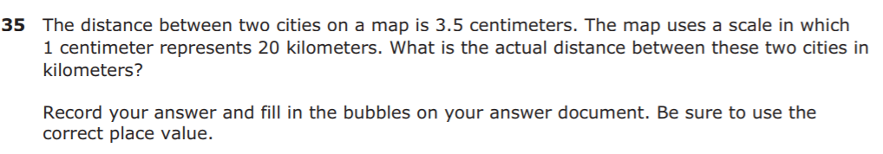
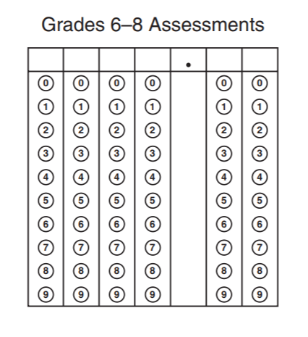
7.5C – 3 (R) nineteen Y
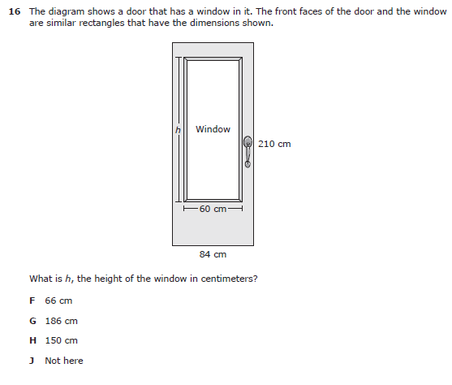
7.5C – 3 (R) twenty Y
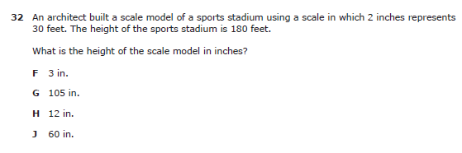

7.6G – 4 (R) twenty two X
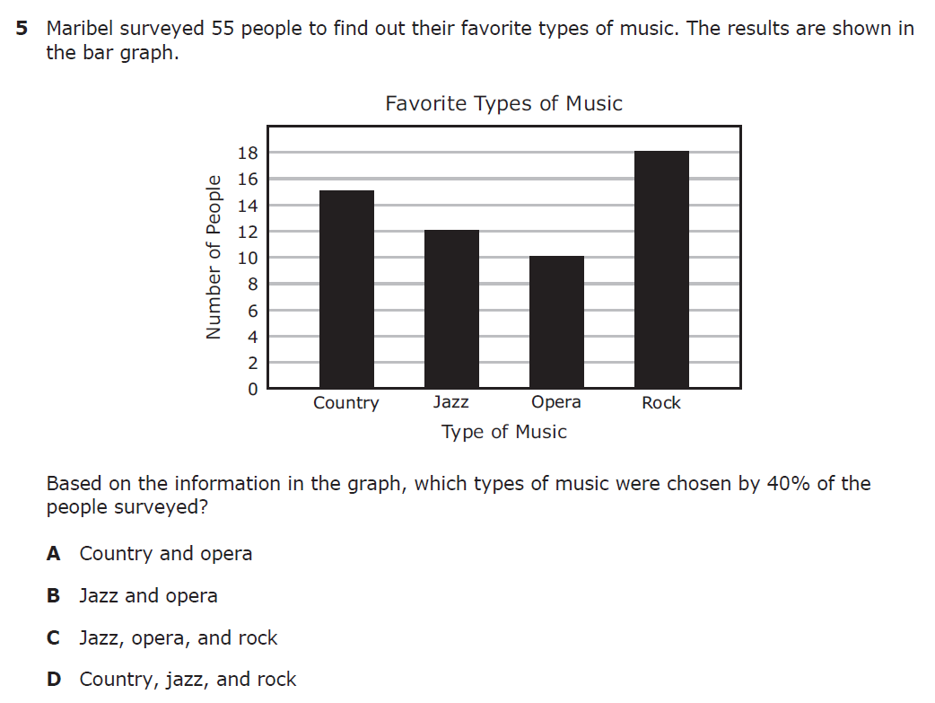
7.6G – 4 (R) twenty three X
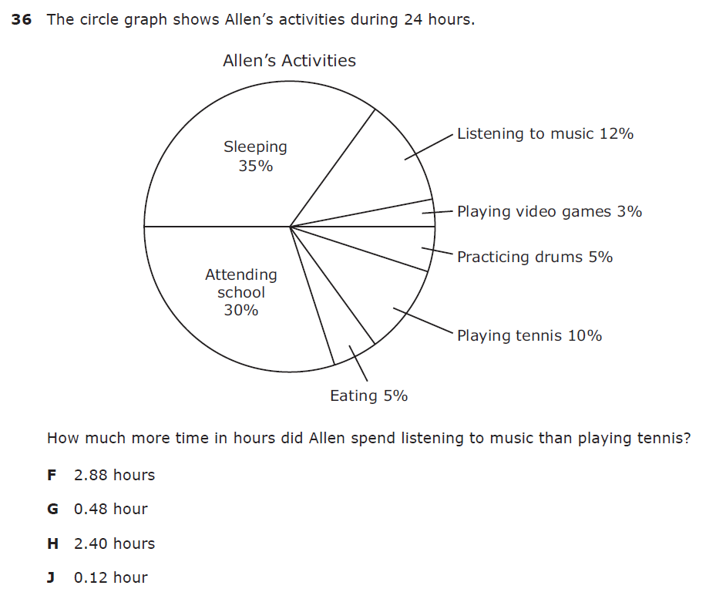
7.6G – 4 (R) fifteen Y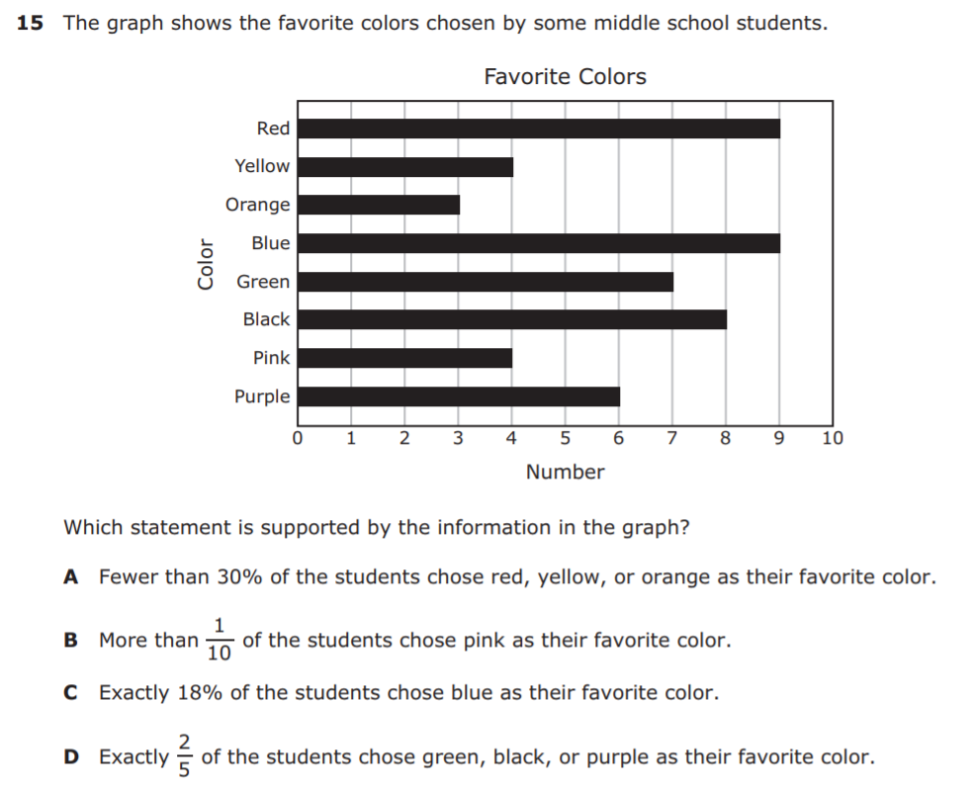
7.6G – 4 (R) sixteen W 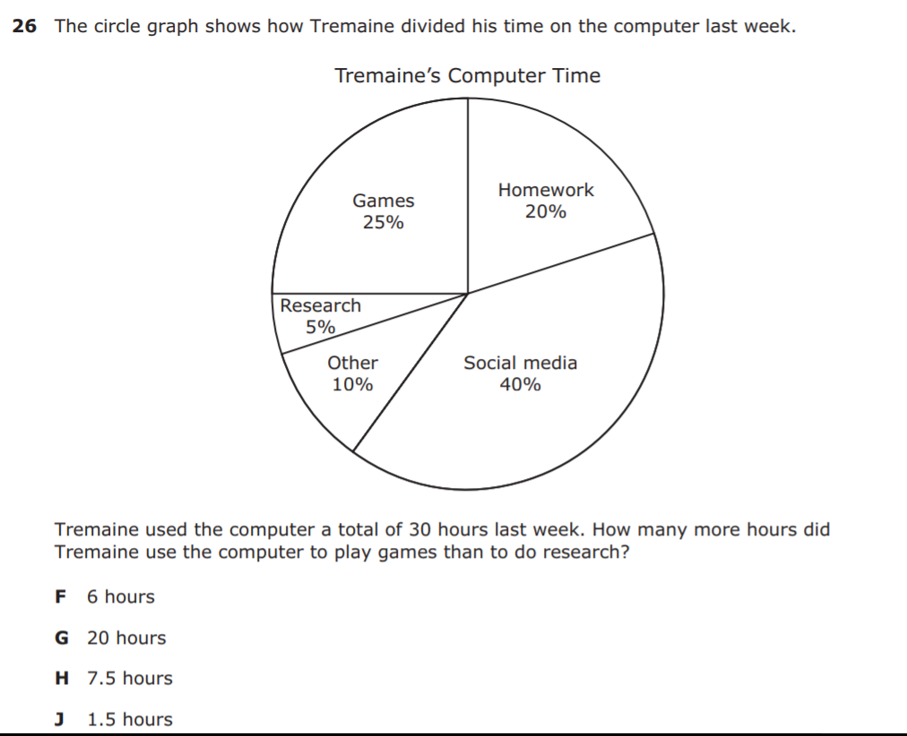
7.6G – 4 (R) sixteen W
7.6G – 4 (R) sixteen Z
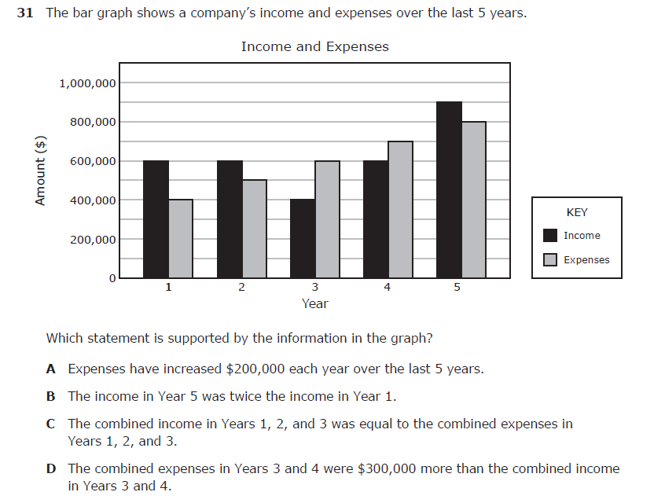
7.6H – 1 (R) twenty four X

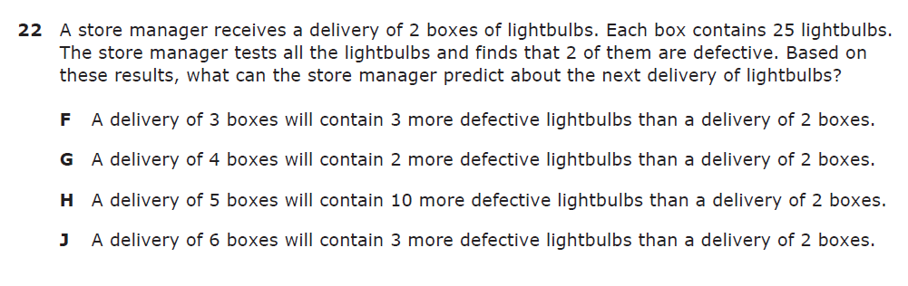

7.6H – 1 (R) twenty five Y
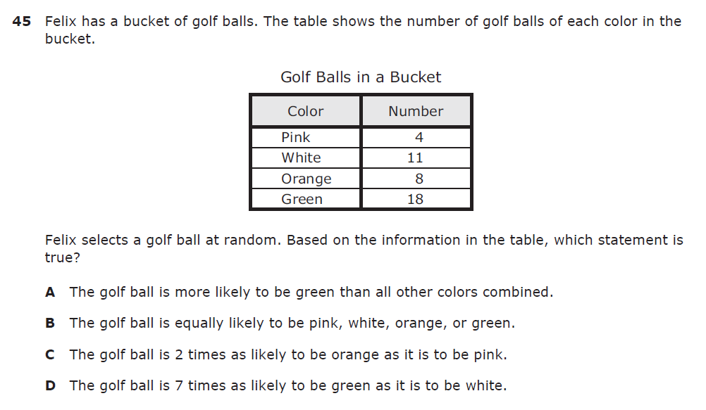

7.6H – 1 (R) seventeen X
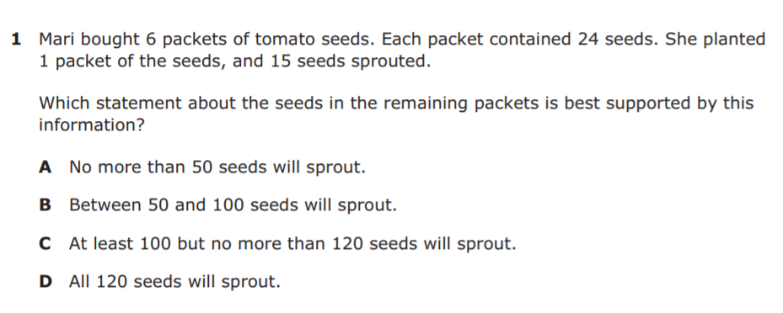

7.6H – 1 (R) eighteen W
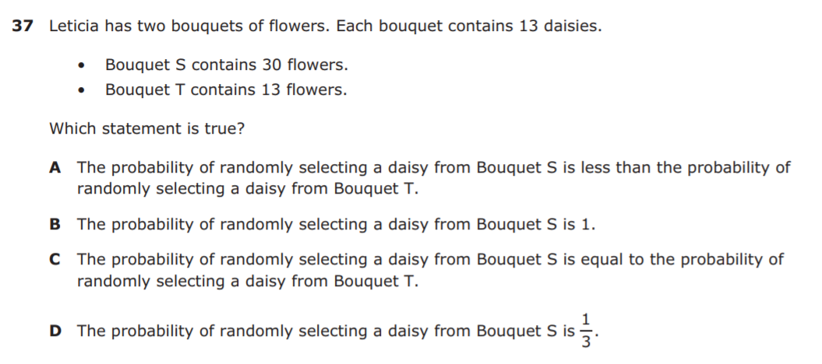

7.6H – 1 (R) twenty four Z
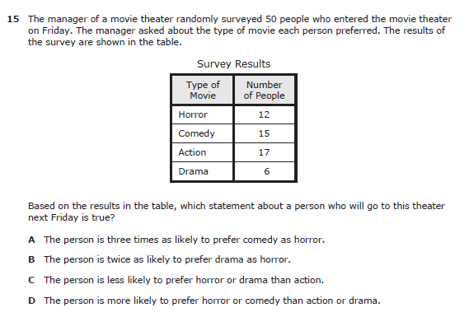
7.6H – 1 (R) twenty five Y
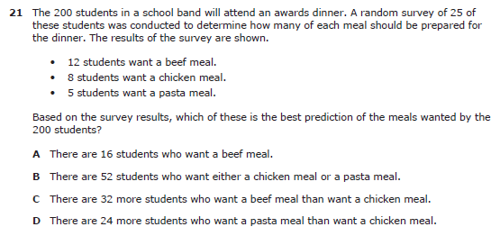

7.6I – 1 (R) twenty six Y
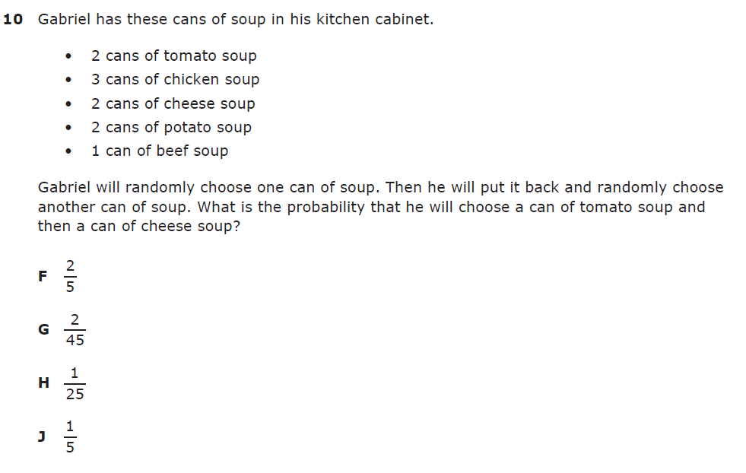
7.6I – 1 (R) twenty seven Z
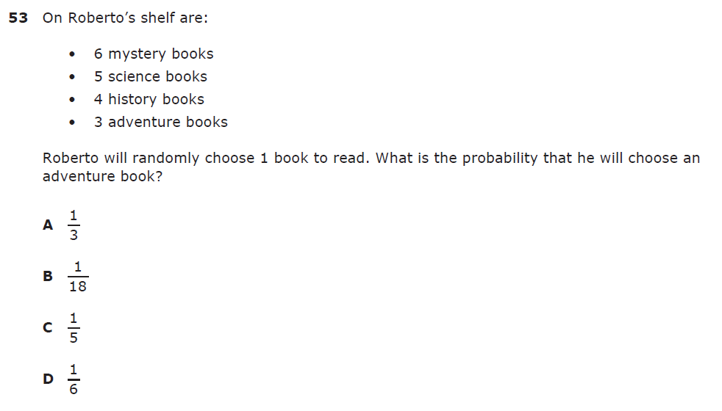

7.6I – 1 (R) nineteen Z
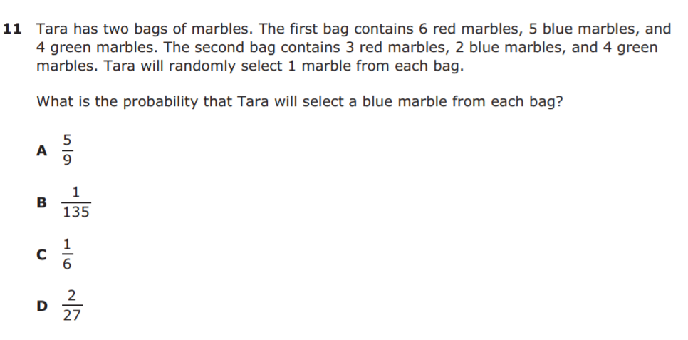

7.6I – 1 (R) twenty X
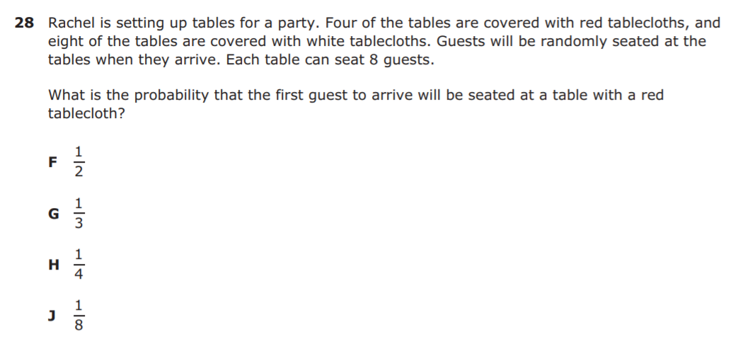

7.6I – 1 (R) sixteen Z
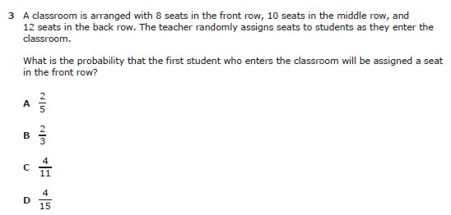

7.6I – 1 (R) seventeen W
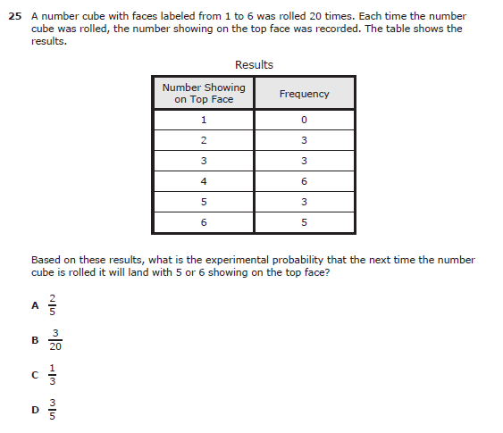
7.7A – 2 (R) twenty eight W
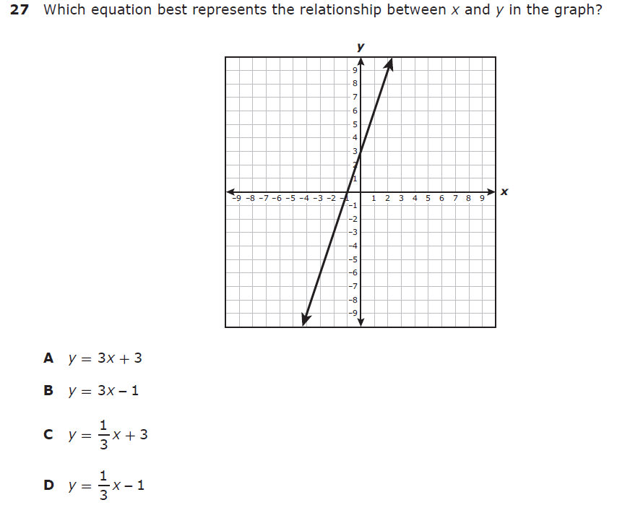
7.7A – 2 (R) twenty nine X
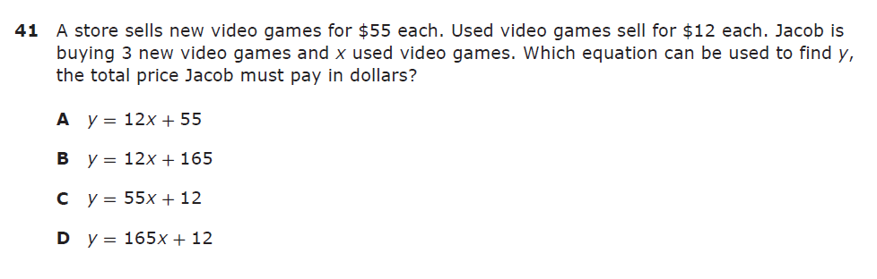

7.7A – 2 (R) thirty Y
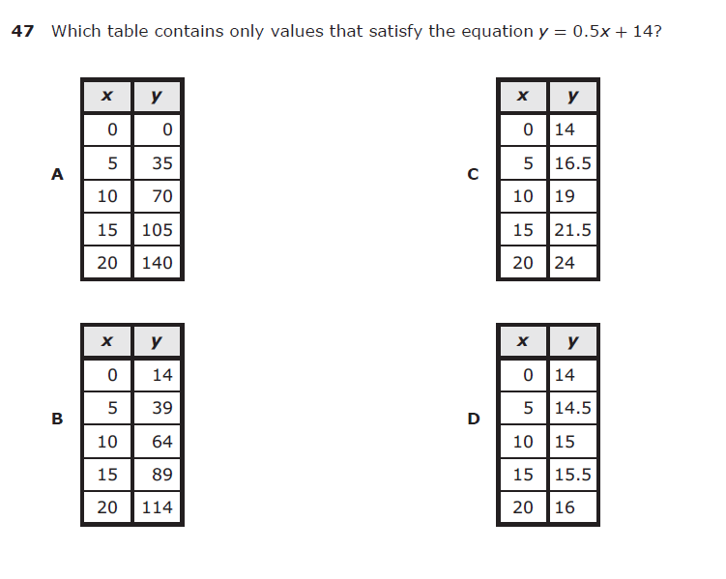
7.7A – 2 (R) twenty one Z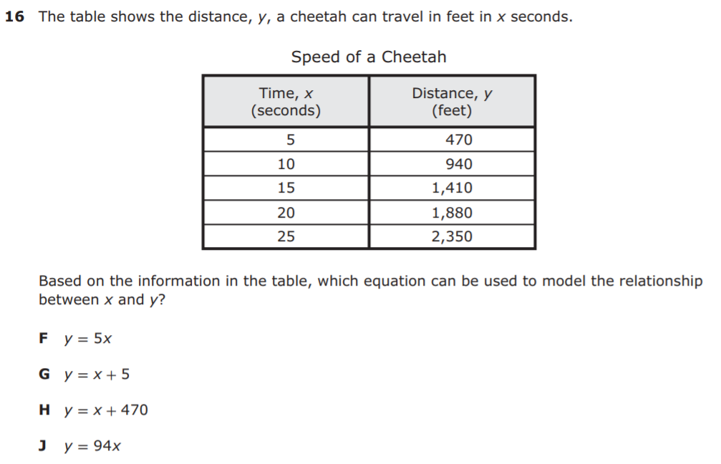
7.7A – 2 (R) twenty two Z
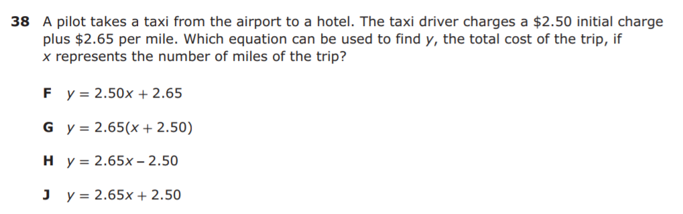

7.7A – 2 (R) twenty One Z
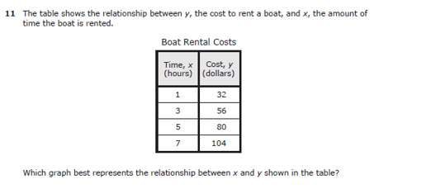
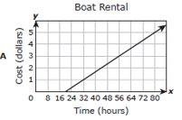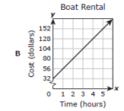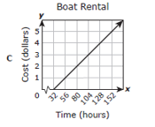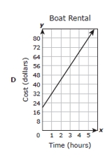
7.7A – 2 (R) twenty two Y
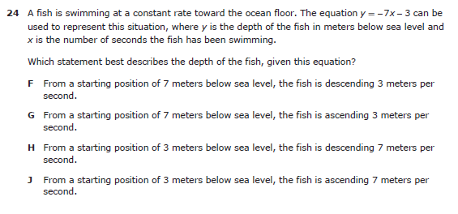

7.9A – 3 (R) thirty one X
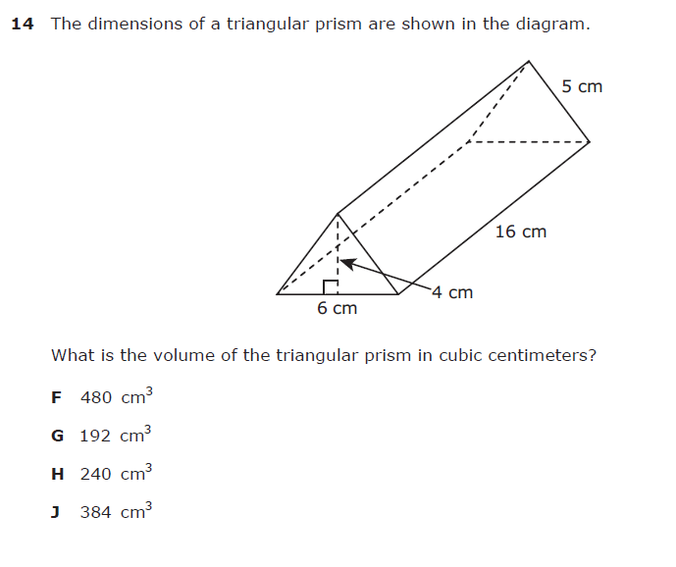
7.9A – 3 (R) thirty two W
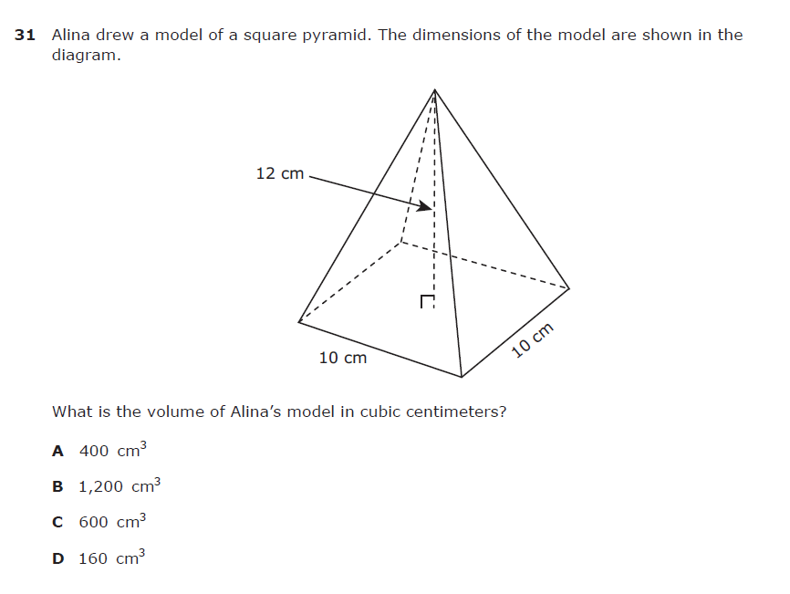
7.9A – 3 (R) thirty three Y
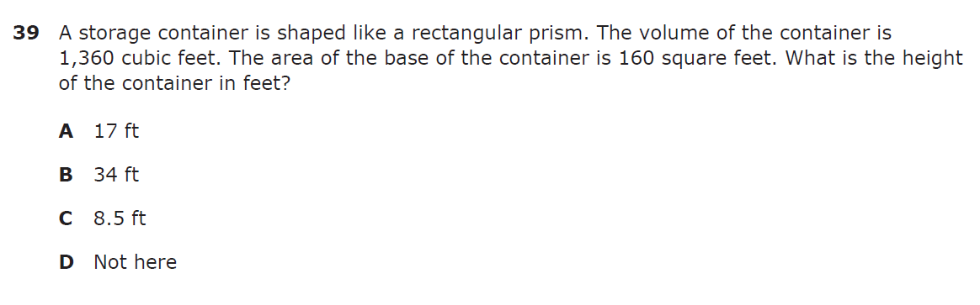

7.9A – 3 (R) twenty three W
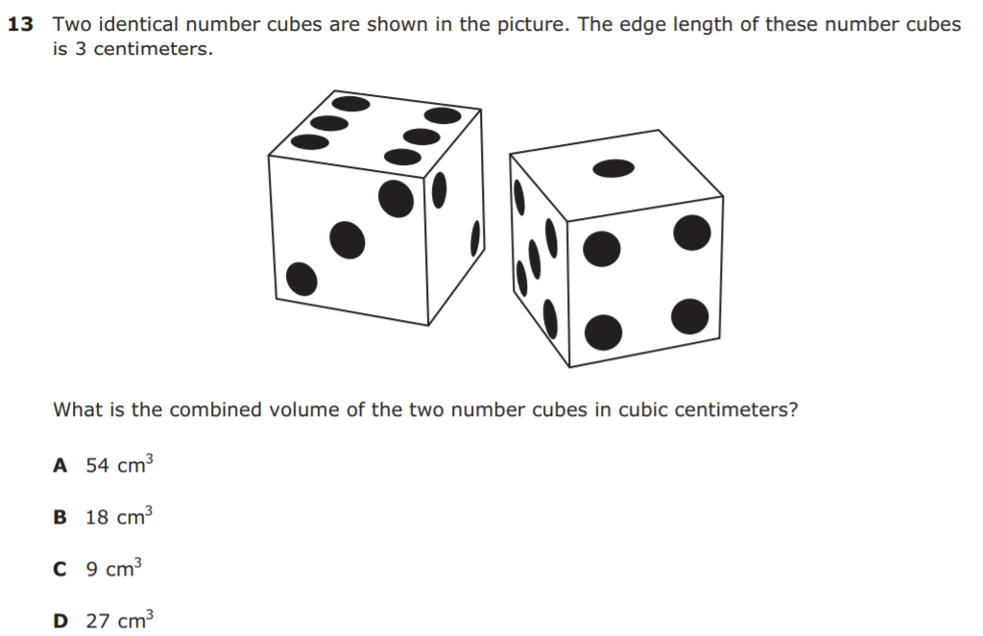
7.9A - 3 (R.) twenty four 18
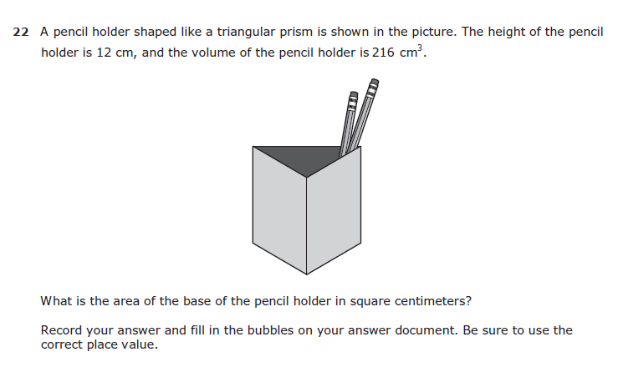

7.9A - 3 (R.) twenty four Y
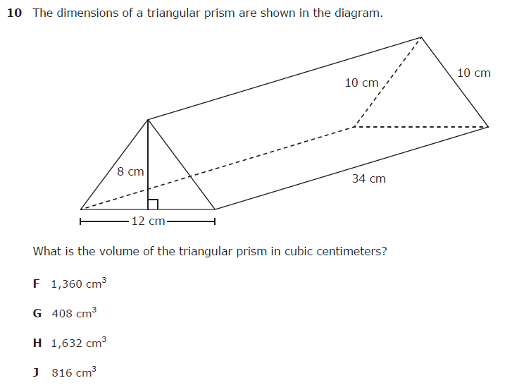
7.9A - 3 (R.) twenty four W
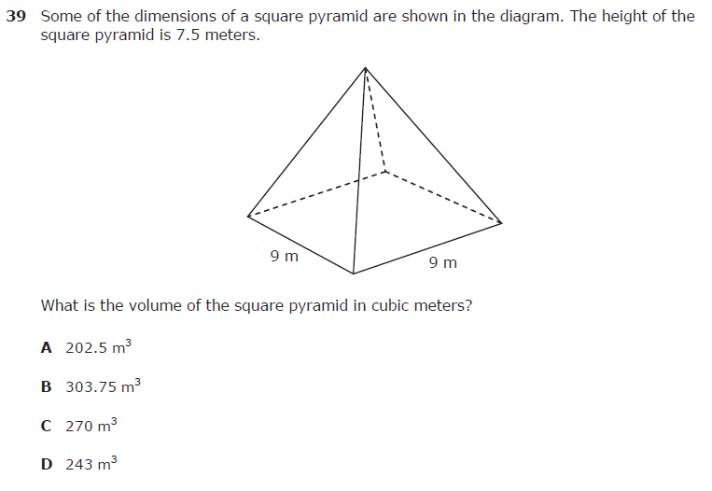

7.9B – 3 (R) thirty four Z
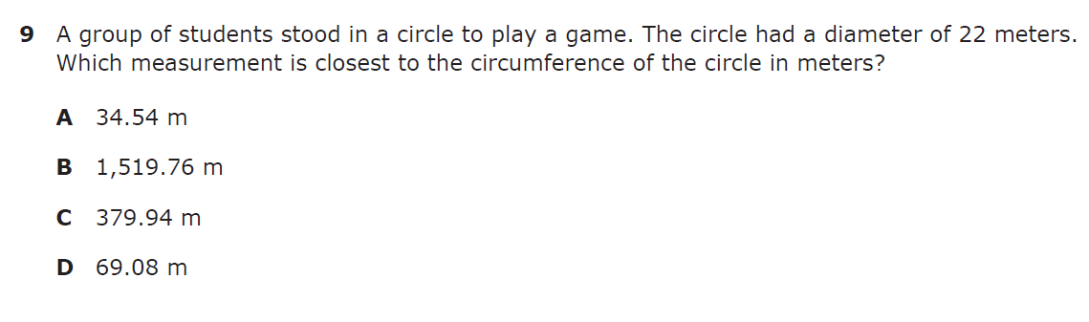

7.9B – 3 (R) thirty five Y
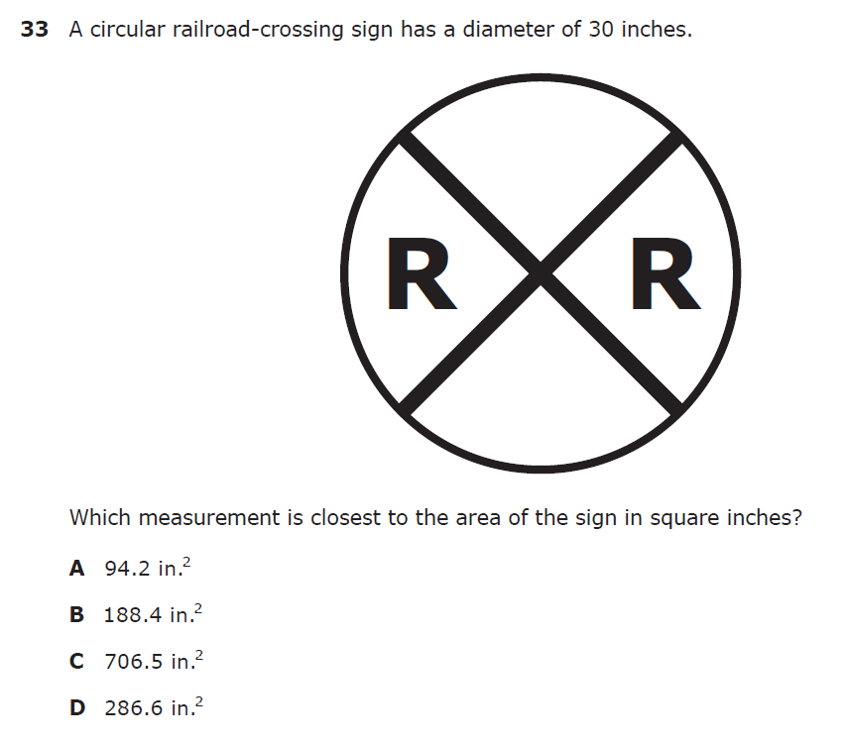
7.9B – 3 (R) thirty six X
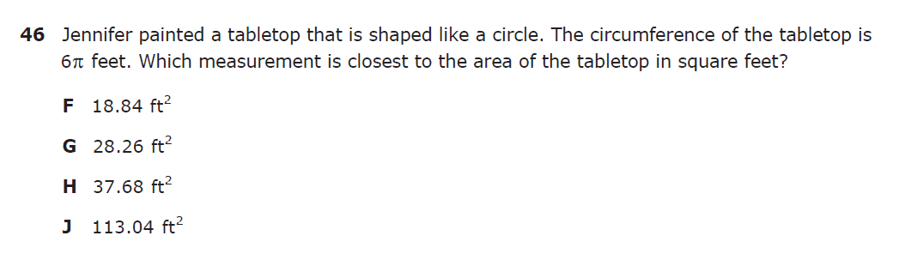

7.9B – 3 (R). twenty five X

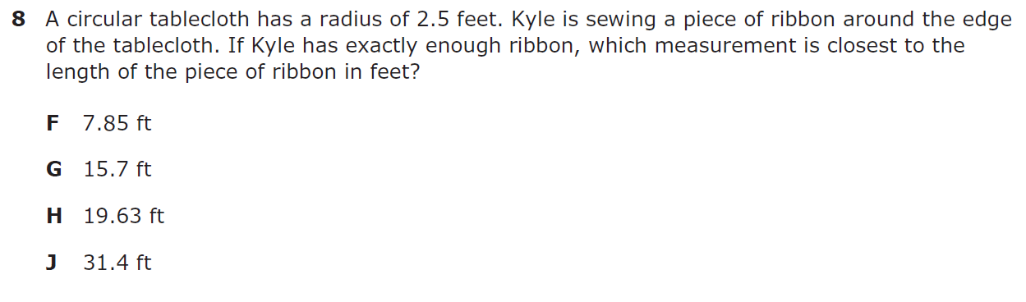

7.9B – 3 (R.) twenty six Y
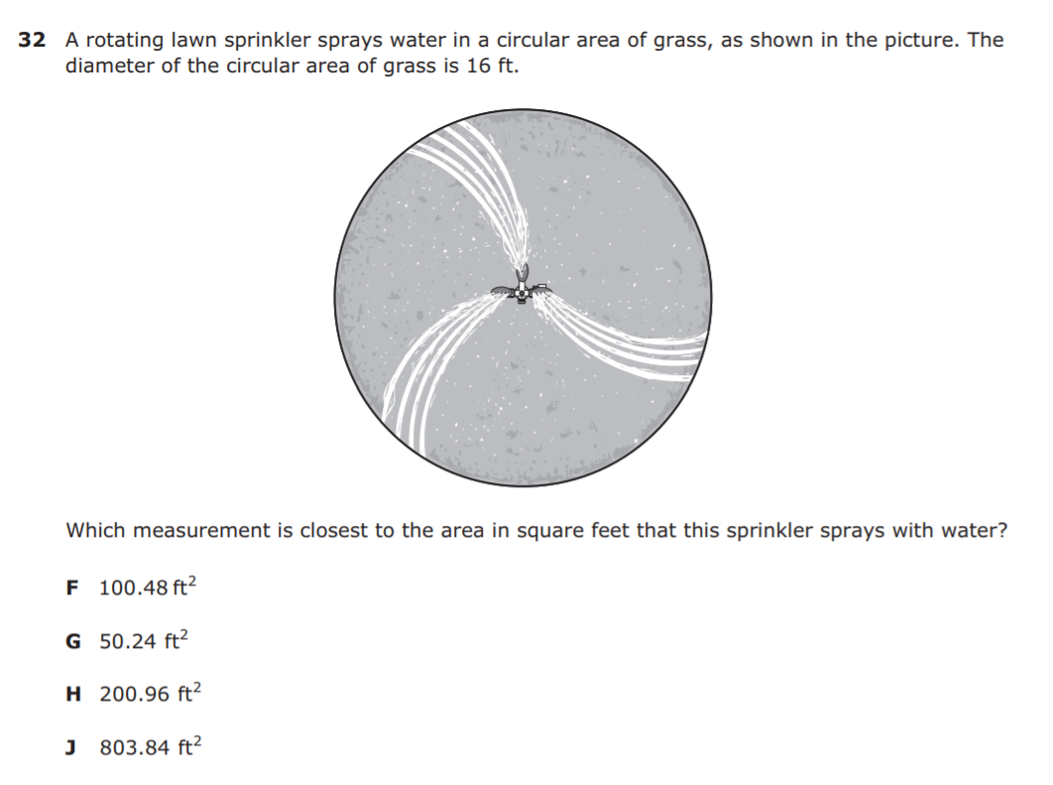
7.9B – 3 (R.) twenty six W
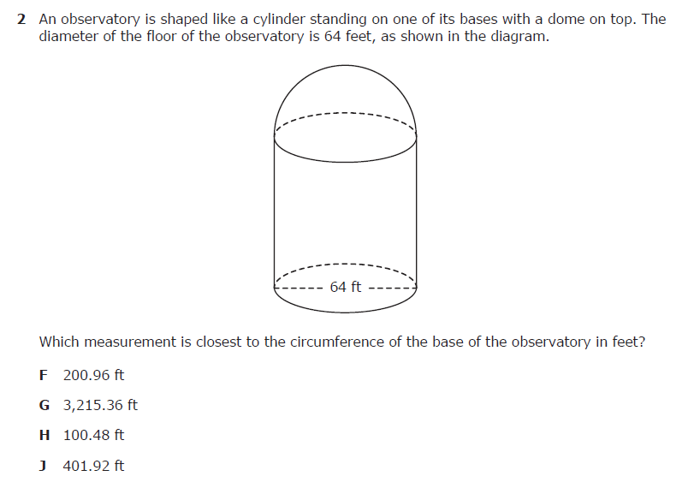
7.9B – 3 (R.) twenty seven Z
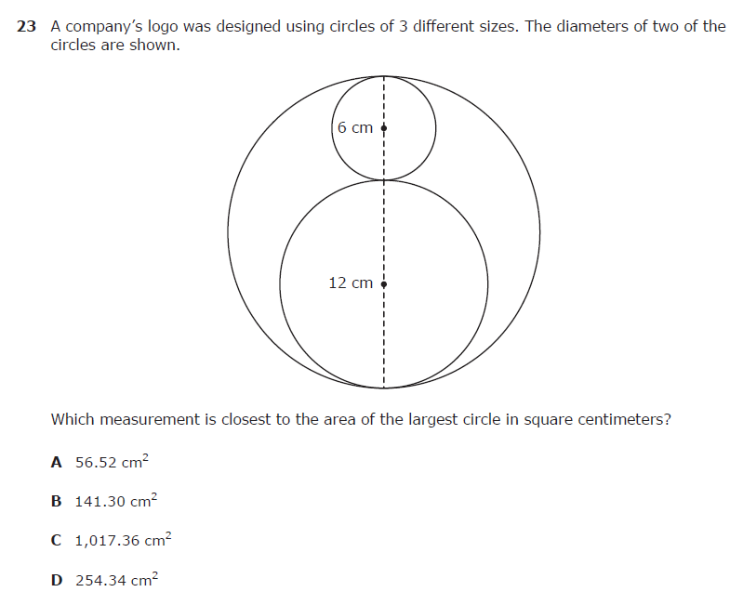
7.9C – 3 (R) thirty seven X
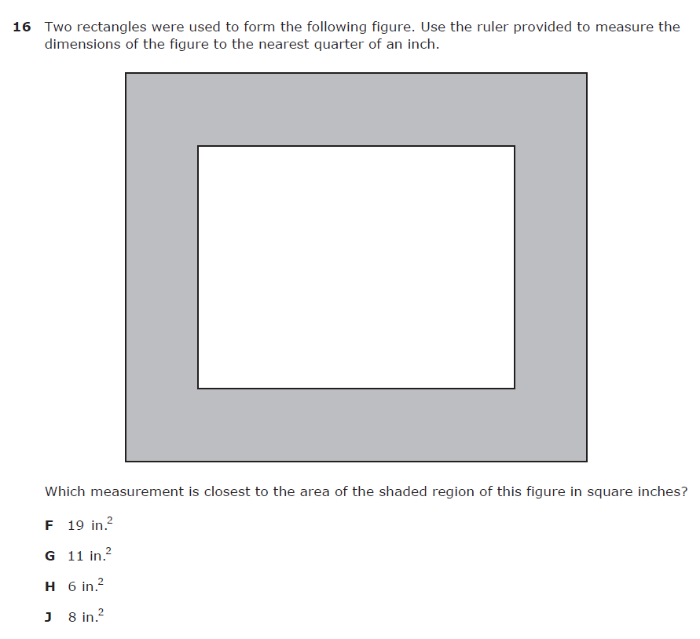
7.9C – 3 (R) thirty eight Z
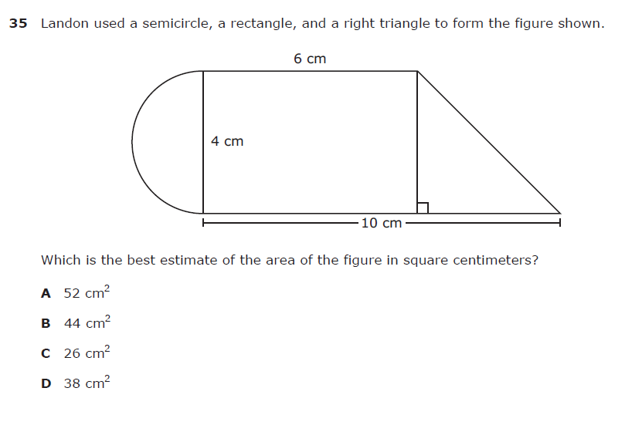
7.9C – 3 (R) thirty nine W
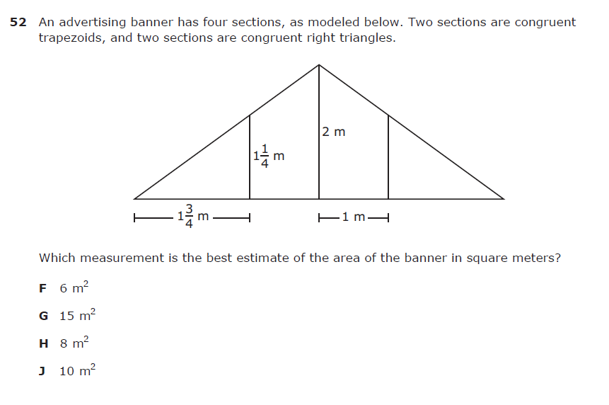
7.9C – 3 (R.) twenty seven W
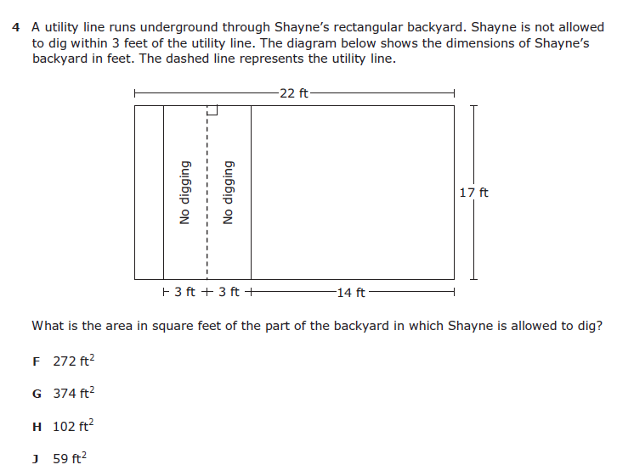
7.9C – 3 (R.) twenty eight Z
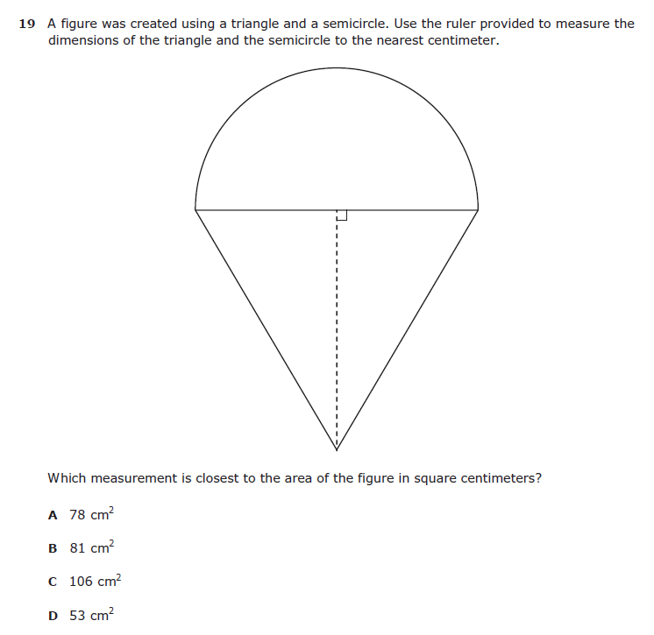
7.9C – 3 (R.) twenty nine X
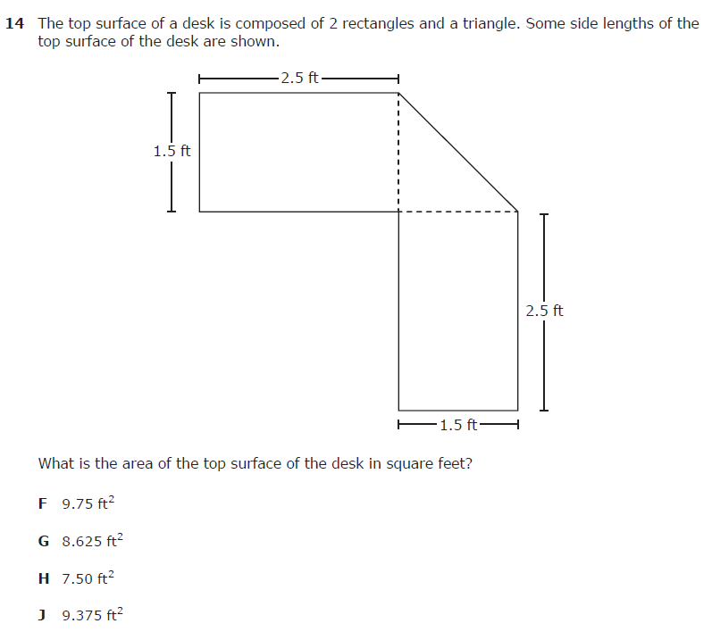
7.9C – 3 (R.) thirty Y
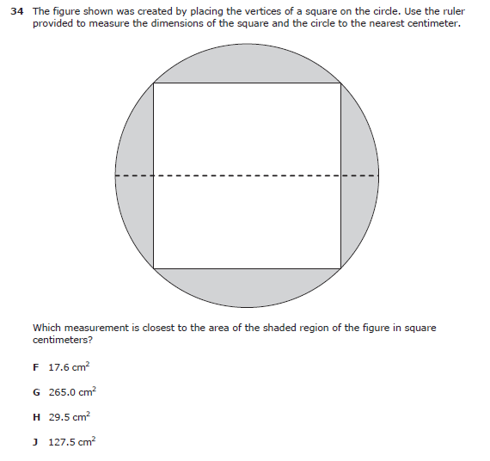
7.11A – 2 (R) thirty three Z
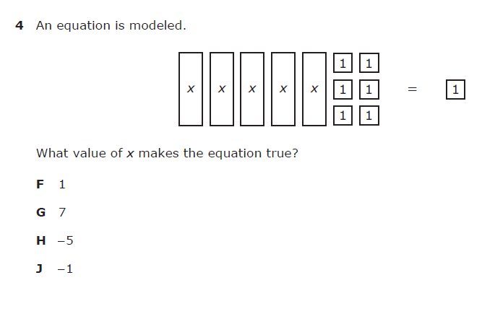
7.11A – 2 (R) thirty four Z
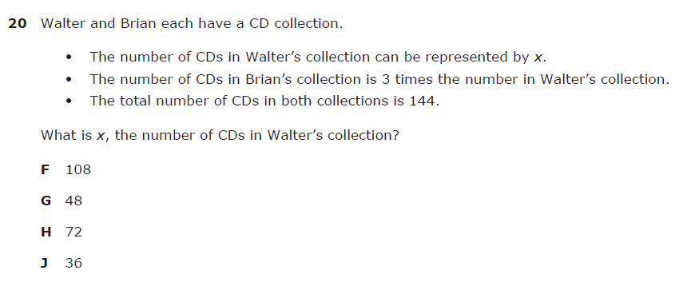

7.11A – 2 (R) thirty five -27
7.11A – 2 (R) thirty six W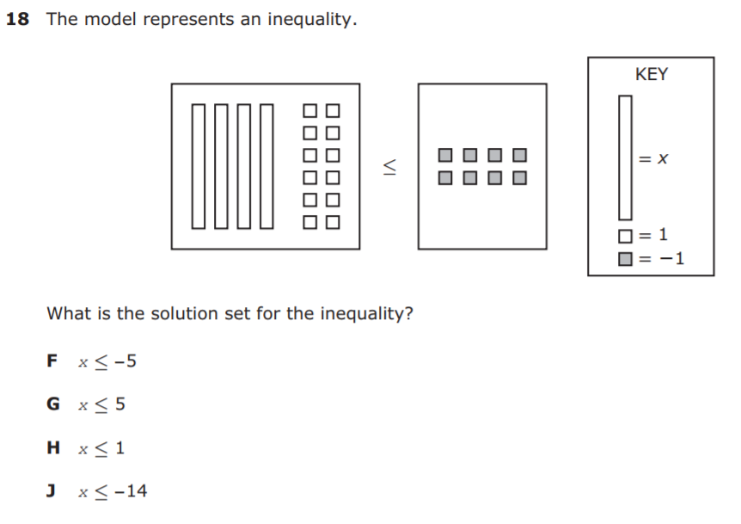
7.11A – 2 (R) thirty seven Z
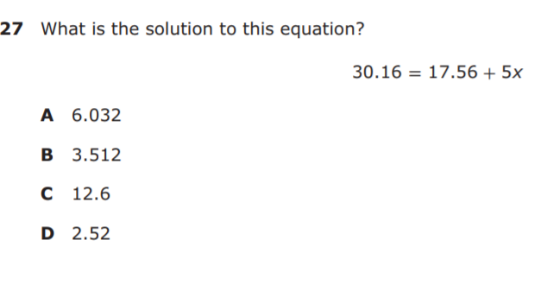

7.11A – 2 (R) thirty eight X
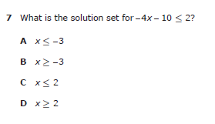

7.11A – 2 (R) thirty nine Z
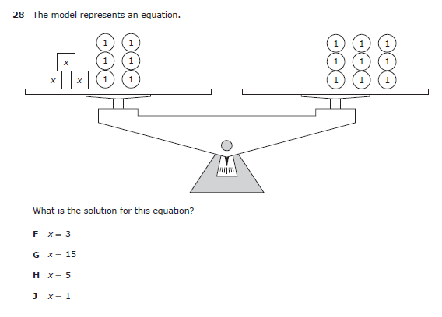
7.12A – 4 (R) forty eight W
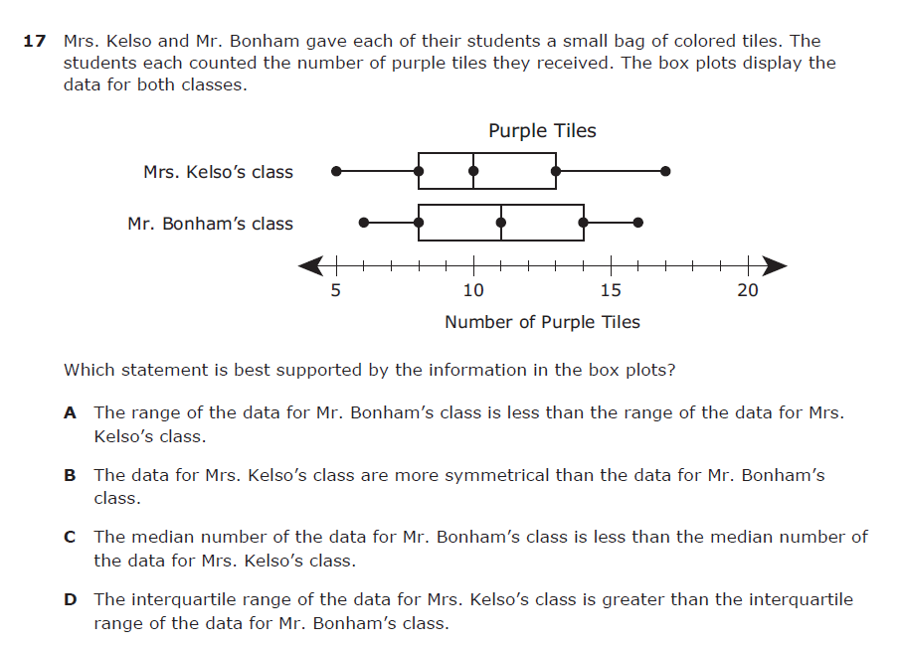
7.12A – 4 (R) forty nine Z
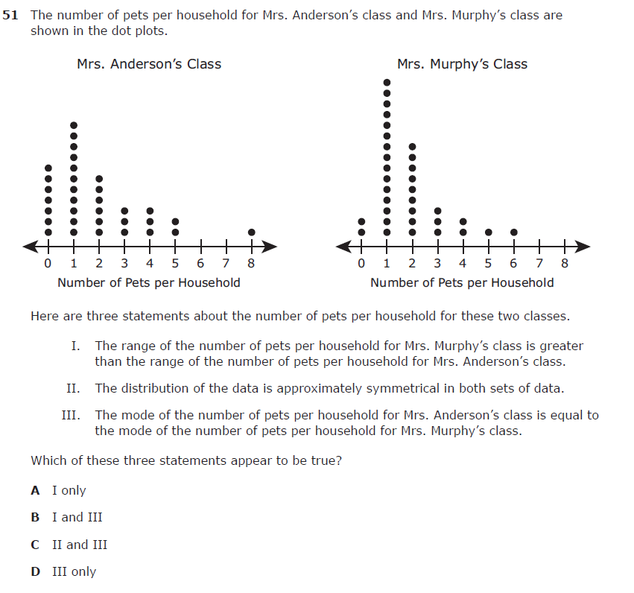
7.12A – 4 (R) thirty six Y
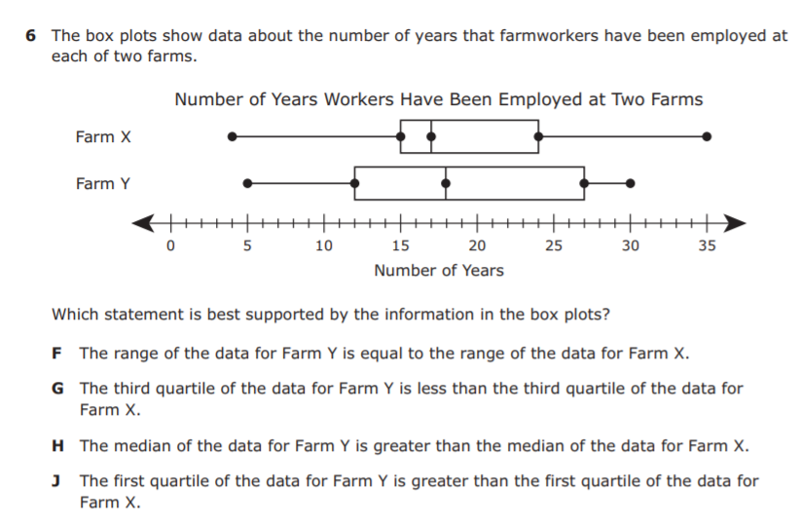
7.12A – 4 (R) thirty seven Y
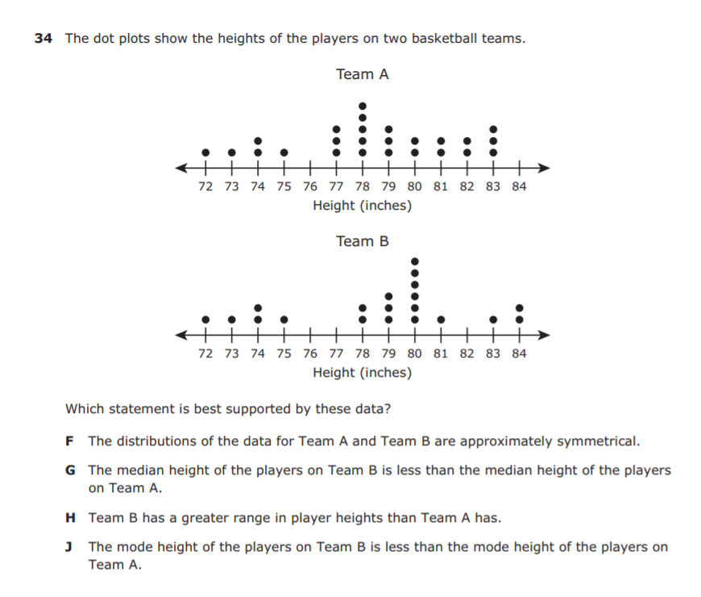
7.12A – 4 (R) thirty eight Y
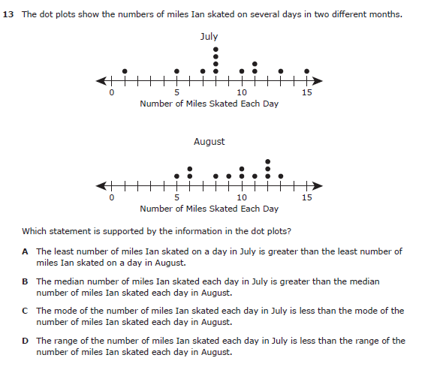
7.12A – 4 (R) thirty nine X
